

Lab – Windows Task Manager

Introduction

In this lab, you will explore Task Manager and manage processes from within Task Manager.

Part 1: Working in the Processes tab

Part 2: Working in the Services tab

Part 3: Working in the Performance tab

Background / Scenario

The Task Manager is a system monitor program that provides information about the processes and programs running on a computer. It also allows the termination of processes and programs and modification of process priority.

Required Resources

- A Windows PC with Internet access

Part 1: Working in the Processes tab

- Open a command prompt and a web browser.

Microsoft Edge is used in this lab; however, any web browser will work. Just substitute your browser name whenever you see Microsoft Edge.

- Right-click the Task bar to open Task Manager. Another way to open the Task Manager is to press Ctrl-Alt-Delete to access the Windows Security screen and select Task Manager.

© Cisco and/or its affiliates. All rights reserved. Cisco Confidential Page 1 of 11 www.netacad.com
Lab – Windows Task Manager

- Click More details to see all the processes that are listed in the Processes tab.
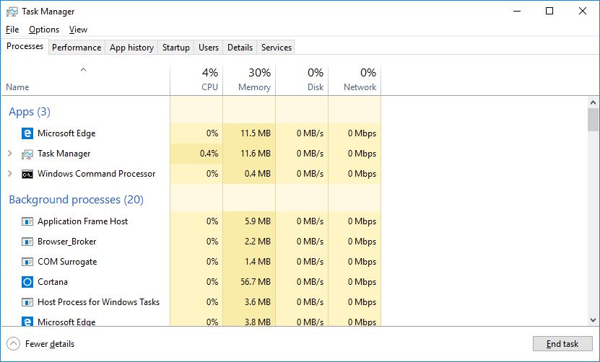

- Expand the Windows Command Processor heading. What is listed under this heading?

Console Window Host and Windows Command Processor

- There are three categories of processes listed in the Processes tab: Apps, Background processes, and Windows processes.

o The Apps are the applications that you have opened, such as Microsoft Edge, Task Manager, and Windows Command Processor, as shown in the figure above. Other applications that are opened by the users, such as web browsers and email clients, will also be listed here.

o The Background processes are executed in the background by applications that are currently open.

o The Windows processes are not shown in the figure. Scroll down to view them on your Windows PC. Windows processes are Microsoft Windows services that run in the background.

© Cisco and/or its affiliates. All rights reserved. Cisco Confidential Page 2 of 11 www.netacad.com

Lab – Windows Task Manager

Some of the background processes or Windows processes may be associated with foreground processes. For example, if you open a command prompt window, the Console Window Host process will be started in the Windows process section, as shown below.
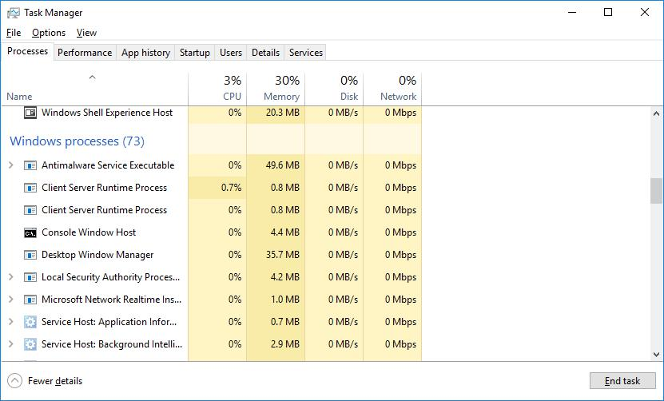

- Right-click Console Window Host and select Properties. What is the location of this filename and location of this process?

розташування імені файлу – шлях до файлу у файловій системі (C:\Windows\System32)

- Close the command prompt window. What happens to Windows Command Processor and Console Window Host when the command prompt window is closed?

Пропали із списку Програм

© Cisco and/or its affiliates. All rights reserved. Cisco Confidential Page 3 of 11 www.netacad.com

Lab – Windows Task Manager

h. Click the Memory heading. Click the Memory heading a second time.
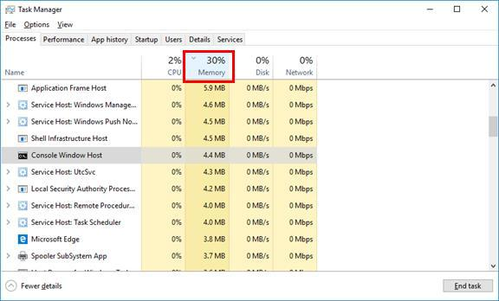

What effect does this have on the columns?

Колонки посортувались відповідно до кількость пам’яті, яку використовують, від найбільшого до найменшого (якщо клікнути туди ж ще раз, будуть від найменшошго до найбільшого)

- Right-click on the Memory heading, and then select Resource values > Memory > Percents.

© Cisco and/or its affiliates. All rights reserved. Cisco Confidential Page 4 of 11 www.netacad.com

Lab – Windows Task Manager
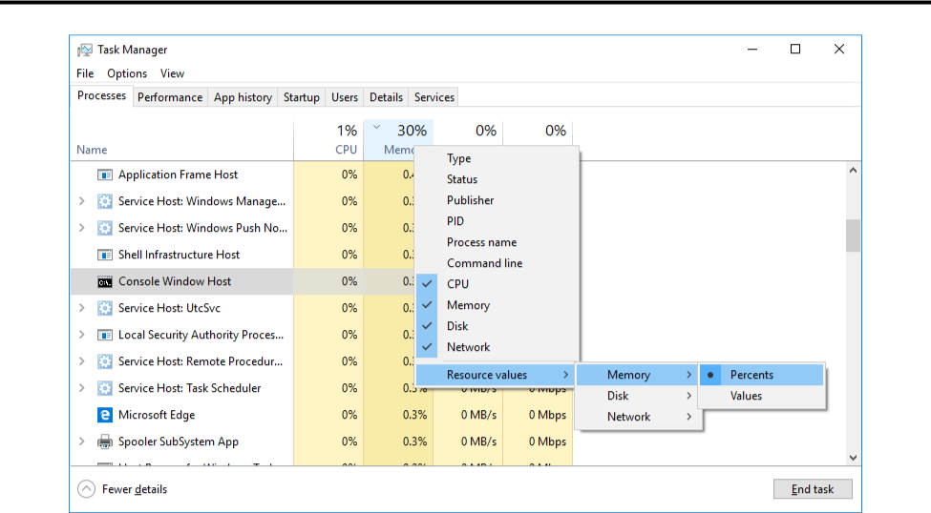

What affect does this have on the Memory column?

Тепер бачимо використання пам’яті не в Мб а у %

How could this be useful?
Якщо користувач не розбирається добре у комп’ютерах і не вміє рахувати свою оперативку, то числа у відсотках будуть набагато зрозуміліші
- Return to the Task Manager. Click the Name heading.

© Cisco and/or its affiliates. All rights reserved. Cisco Confidential Page 5 of 11 www.netacad.com

Lab – Windows Task Manager
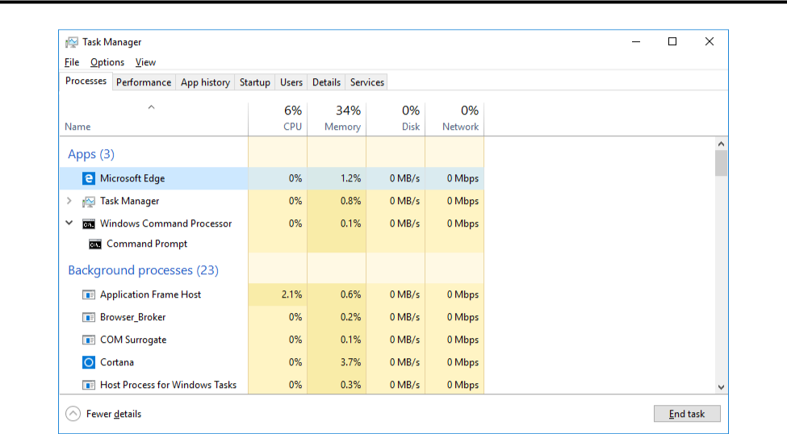

- Double-click the Microsoft Edge. What happens?

Відкриється список всіх дочірніх процесів

- Right-click Microsoft Edge, and select End task. What happens to the web browser windows?

Вікно браузера закриється

© Cisco and/or its affiliates. All rights reserved. Cisco Confidential Page 6 of 11 www.netacad.com

Lab – Windows Task Manager

Part 2: Working in the Services tab

- Click the Services tab. Use the scroll bar on the right side of the Services window to view all the services listed.
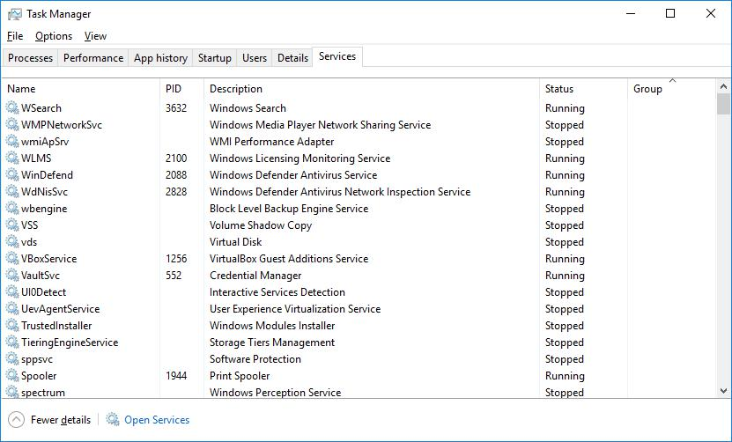

What statuses are listed?

Зупинено / виконується

© Cisco and/or its affiliates. All rights reserved. Cisco Confidential Page 7 of 11 www.netacad.com

Lab – Windows Task Manager

Part 3: Working in the Performance tab

a. Click the Performance tab.
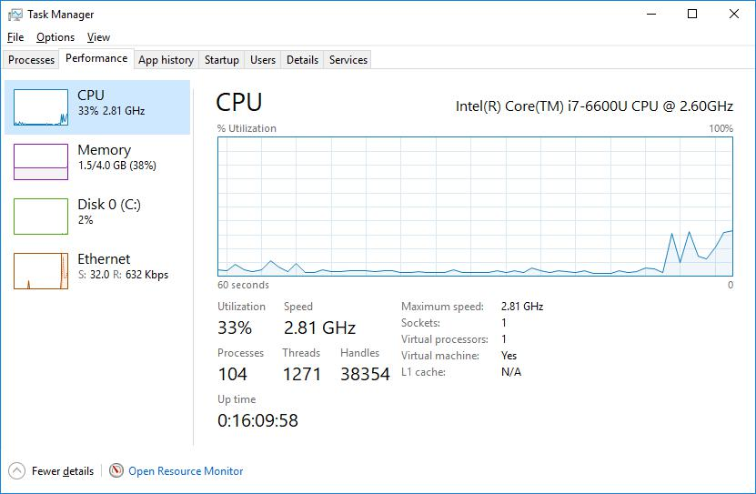

How many threads are running?

4069

How many processes are running?

350

© Cisco and/or its affiliates. All rights reserved. Cisco Confidential Page 8 of 11 www.netacad.com

Lab – Windows Task Manager

b. Click the Memory in the left panel of the Performance tab.
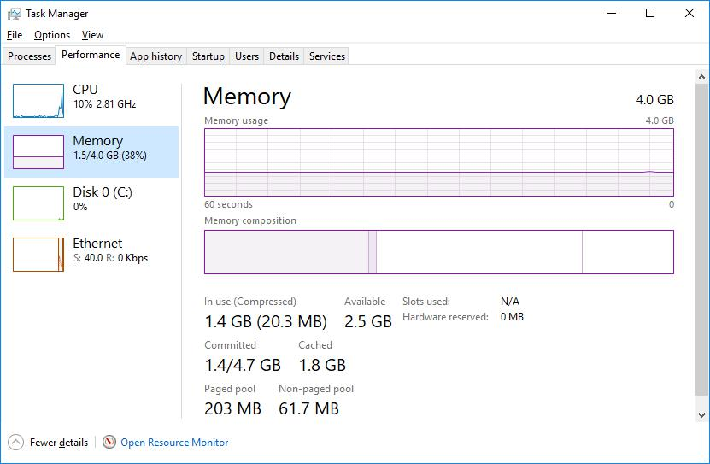

What is the total physical memory (MB)?

8гб_______

What is the available physical memory (MB)?

2.3 гб________

How much physical memory (MB) is being used by the computer?

5.5 гб________________________________

© Cisco and/or its affiliates. All rights reserved. Cisco Confidential Page 9 of 11 www.netacad.com

Lab – Windows Task Manager

- Click the Ethernet Chart in the left panel of the Performance tab.
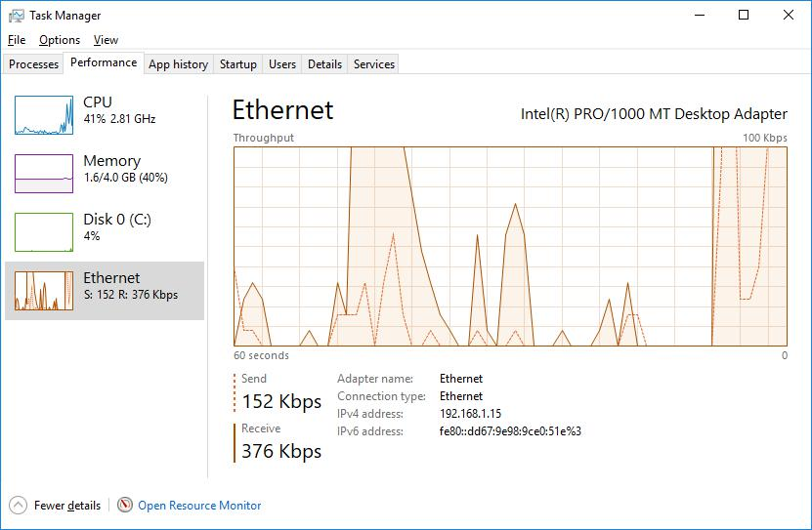

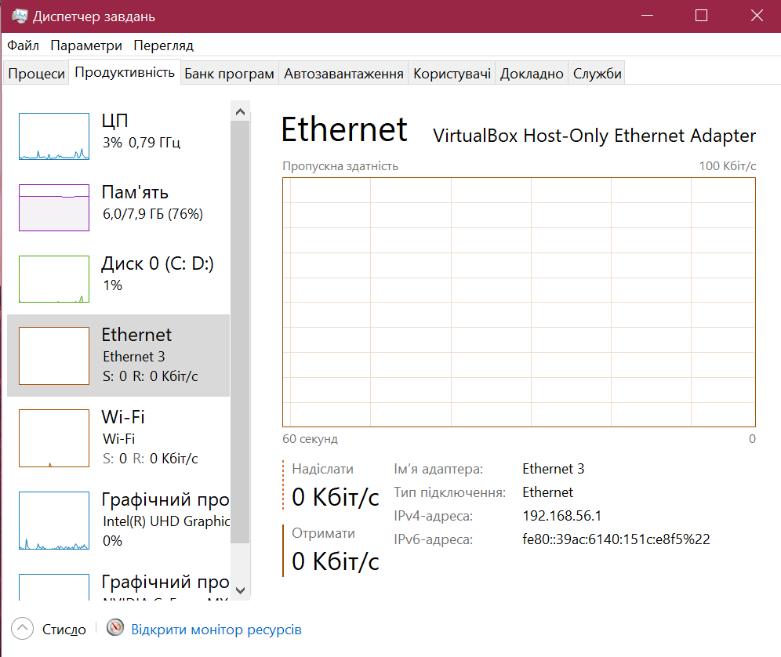
What is the link speed?

0

What is the IPv4 address of the PC?

192.168.56.1

© Cisco and/or its affiliates. All rights reserved. Cisco Confidential Page 10 of 11 www.netacad.com

Lab – Windows Task Manager

- Click Open Resource Monitor to open the Resource Monitor utility from the Performance tab in Task Manager.
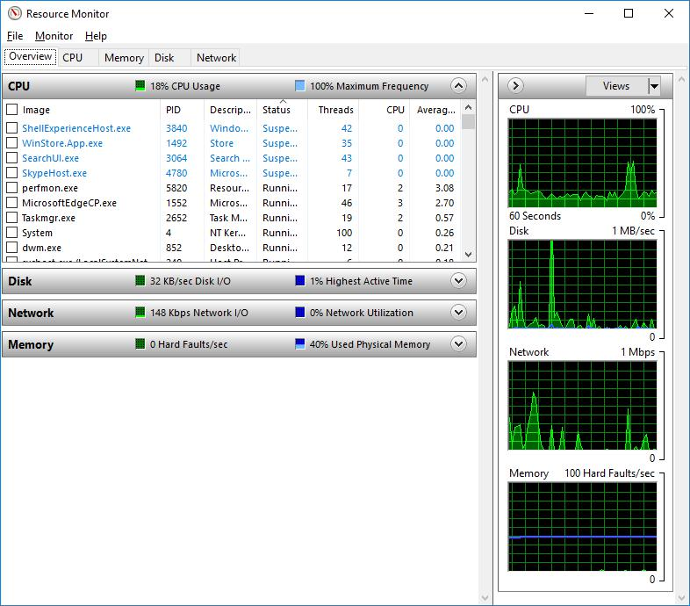

Reflection

Why is it important for an administrator to understand how to work within the Task Manager?

Диспетчер задач – зручний та простий у використанні, дає змогу контролювати всі запущені процеси Зокрема, він допомагає виявляти підозрілу активність файлів на комп’ютері, тобто шукати віруси, що може бути корисно не тільки адміністраторам але і простим користувачам

© Cisco and/or its affiliates. All rights reserved. Cisco Confidential Page 11 of 11 www.netacad.com

